Is This The End of Halloween?

As told by Grandpa Joe

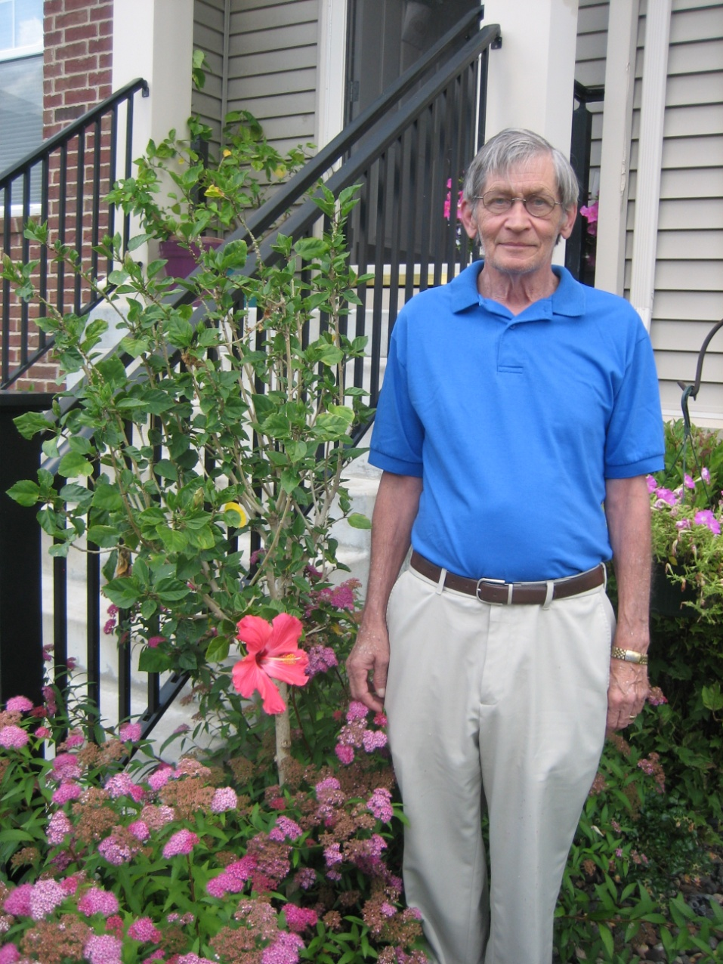

Change name and insert picture of giver of book

Copyright © 2016 Xanadu Inc. See Instructions on how to tailor this book to your child/children and permitted uses, copying and licensing.

**Millions, no billions came**

**They ate all the plants and sugar cane.**

And

[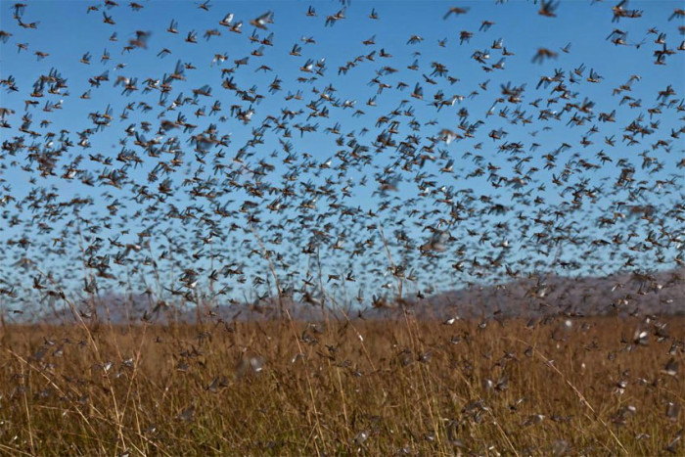](https://www.google.com/url?sa=i&rct=j&q=&esrc=s&source=images&cd=&cad=rja&uact=8&ved=0ahUKEwiJ84ndie7KAhVLVD4KHUBECWEQjRwIBw&url=https://heiscomingblog.wordpress.com/2015/07/30/biblical-scene-southern-russia-plagued-by-tens-of-thousands-of-locusts-darkening-skies-and-threatening-crops-pics-and-video/&psig=AFQjCNH-JY45YK7nP3xkaHlhqkjANL0DUg&ust=1455223904283648)

**Some were green some brown some with spots**

**And they all wanted food, lots and lots**

**And**

**They ate all the plants,**

**all the sugar cane.**

**To the insects everything looked the same.**

**They were red and green**

**and some with spots**

**The only thing the same is**

**they ate lots and lots.**

[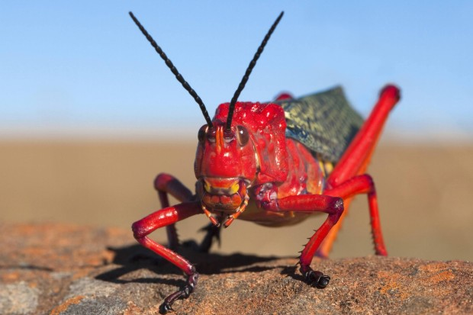](https://www.google.com/url?sa=i&rct=j&q=&esrc=s&source=images&cd=&cad=rja&uact=8&ved=0ahUKEwi106iFjO7KAhVCWD4KHchwDmEQjRwIBw&url=https://featuredcreature.com/the-devilishly-detailed-milkweed-locust/&psig=AFQjCNH-JY45YK7nP3xkaHlhqkjANL0DUg&ust=1455223904283648)

[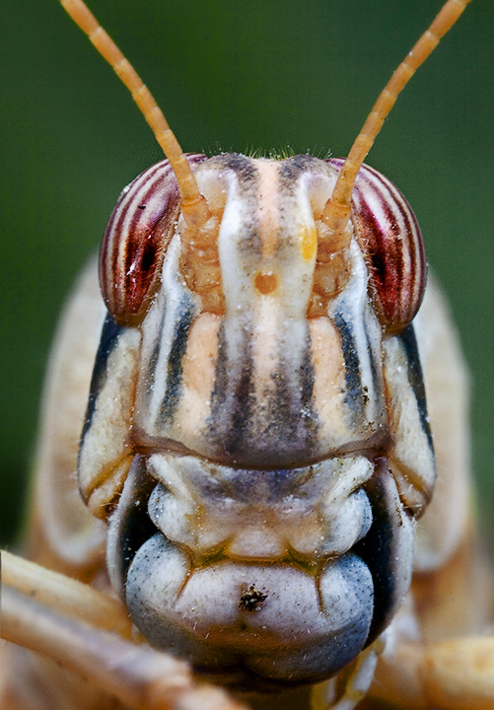](http://www.google.com/url?sa=i&rct=j&q=&esrc=s&source=images&cd=&cad=rja&uact=8&ved=0ahUKEwjz24uei-7KAhXJaT4KHYVcAGAQjRwIBw&url=http://www.pbase.com/image/73354433&psig=AFQjCNH-JY45YK7nP3xkaHlhqkjANL0DUg&ust=1455223904283648)

[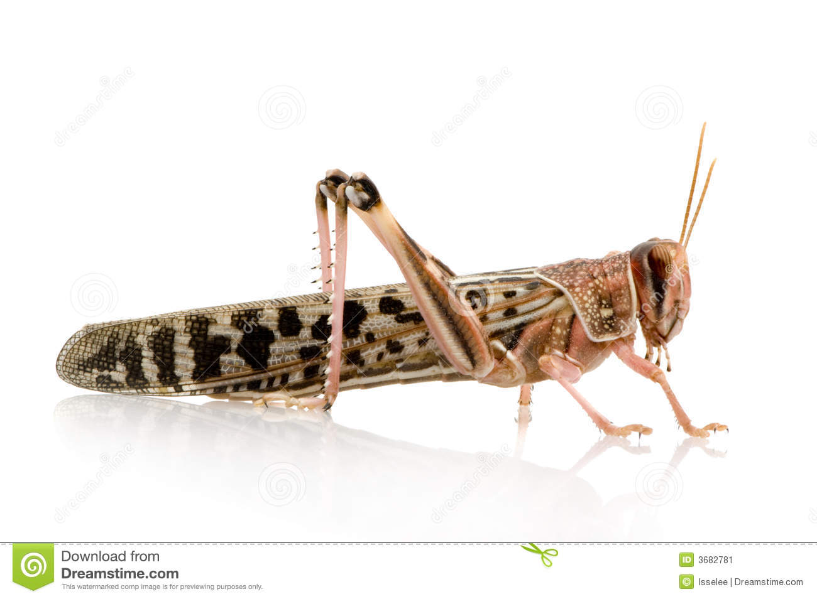](http://www.google.com/url?sa=i&rct=j&q=&esrc=s&source=images&cd=&cad=rja&uact=8&ved=0ahUKEwihwc7Ii-7KAhVBPD4KHSQdD2MQjRwIBw&url=http://www.dreamstime.com/stock-image-desert-locust-schistocerca-gregaria-image3682781&psig=AFQjCNH-JY45YK7nP3xkaHlhqkjANL0DUg&ust=1455223904283648)[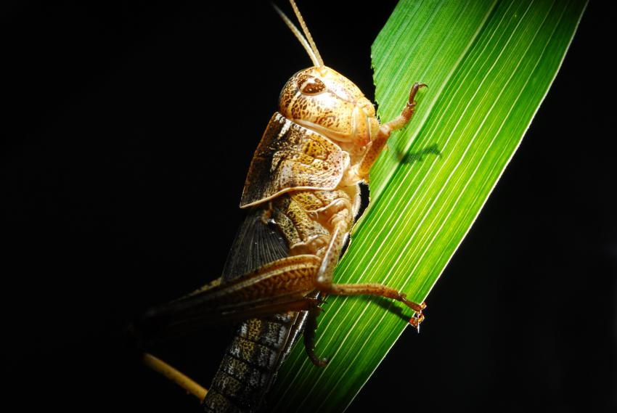](http://www.google.com/url?sa=i&rct=j&q=&esrc=s&source=images&cd=&cad=rja&uact=8&ved=0ahUKEwiTgbGaiu7KAhWMOT4KHVYdCWEQjRwIBw&url=http://phys.org/news/2014-07-locusts-harness-sun-optimum-diet.html&psig=AFQjCNH-JY45YK7nP3xkaHlhqkjANL0DUg&ust=1455223904283648)

**Every hour this made him quite sour.**

**Everyone wanted to keep in touch and it was just too much.**

**He had lost his leap**

**From lack of sleep.**

[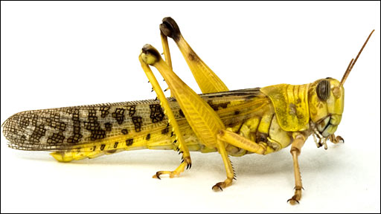](http://www.google.com/url?sa=i&rct=j&q=&esrc=s&source=images&cd=&cad=rja&uact=8&ved=0ahUKEwihu4_Slu7KAhVHQyYKHTDrAdEQjRwIBw&url=http://blogs.bu.edu/bioaerial2012/2012/09/25/the-locust-swarm-a-threat-to-the-global-economy/&psig=AFQjCNGY0qeSTDlTKI6Imqo8JHkea10kbQ&ust=1455227208275004)

**Word spread from church pews**

**and the TV news.**

**They told us to be wary**

**that it was very scary.**

[](https://www.google.com/url?sa=i&rct=j&q=&esrc=s&source=images&cd=&cad=rja&uact=8&ved=0ahUKEwiQruqLgPDKAhVHKCYKHTkUDA4QjRwIBw&url=https://pixabay.com/en/news-globe-earth-world-507772/&psig=AFQjCNGzDtyttPMHDcCtPZHOpcLxAlgy0g&ust=1455290038426286)

[](https://www.google.com/url?sa=i&rct=j&q=&esrc=s&source=images&cd=&cad=rja&uact=8&ved=0ahUKEwiRocStgPDKAhUG6SYKHVP4CsQQjRwIBw&url=https://pixabay.com/en/news-press-newspaper-commenced-644847/&psig=AFQjCNGzDtyttPMHDcCtPZHOpcLxAlgy0g&ust=1455290038426286)

**Don’t go there by train or plane.**

**Beware!!!**

**There’s too many grasshoppers to get there.**

[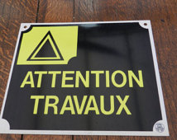](https://www.google.com/url?sa=i&rct=j&q=&esrc=s&source=images&cd=&cad=rja&uact=8&ved=0ahUKEwj4mbbDkPDKAhVF7yYKHR6TAxkQjRwIBw&url=https://www.etsy.com/uk/market/french_vintage_sign&psig=AFQjCNHwCq-rWkSaobGbTJXjMb1nbTwpVQ&ust=1455294009987026)

[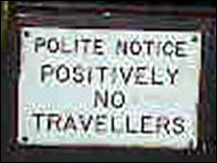](http://www.google.com/url?sa=i&rct=j&q=&esrc=s&source=images&cd=&cad=rja&uact=8&ved=0ahUKEwjpl_D-kPDKAhXI7yYKHQVPDcEQjRwIBw&url=http://news.bbc.co.uk/2/hi/uk_news/wales/north_east/7424203.stm&psig=AFQjCNHwCq-rWkSaobGbTJXjMb1nbTwpVQ&ust=1455294009987026)

[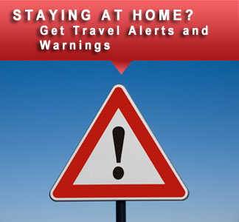](https://www.google.com/url?sa=i&rct=j&q=&esrc=s&source=images&cd=&cad=rja&uact=8&ved=0ahUKEwic8cjIj_DKAhVM7yYKHYPLDggQjRwIBw&url=https://step.state.gov/&psig=AFQjCNHwCq-rWkSaobGbTJXjMb1nbTwpVQ&ust=1455294009987026)

**There may be nothing to eat**

**except a little meat**

**Nothing is left, not a brussel sprout.**

**No cabbage for sauerkraut.**

**If you go it may be your fate**

**To have only hoppers on a plate.**

[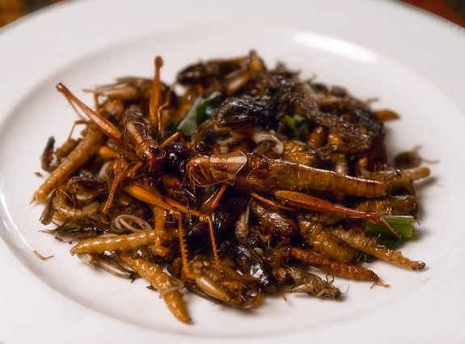](http://www.google.com/url?sa=i&rct=j&q=&esrc=s&source=images&cd=&cad=rja&uact=8&ved=0ahUKEwjN643Jiu7KAhXMHD4KHZB-DGUQjRwIBw&url=http://www.smithsonianmag.com/smart-news/people-in-israel-really-are-eating-swarming-locusts-7802747/&psig=AFQjCNH-JY45YK7nP3xkaHlhqkjANL0DUg&ust=1455223904283648)

**The children asked with a little fear**

**What if they come near to here.**

[](http://www.google.com/url?sa=i&rct=j&q=&esrc=s&source=images&cd=&cad=rja&uact=8&ved=0ahUKEwiCg-qZrPDKAhXJ5CYKHX2HCxQQjRwIBw&url=http://www.playbuzz.com/alfiew10/whats-your-biggest-fear&psig=AFQjCNGfhswZZqBD9zS1QKrV9QqkHFx1-g&ust=1455301898514299)

**The news went on.**

**“We know it’s bazaar**

**But we’ve been told**

**they don’t like it this far.”**

**“But you better go to the grocery mart**

**and put vegetables in your cart.**

**For some time there will be a lack**

**until they have time to grow back.”**

[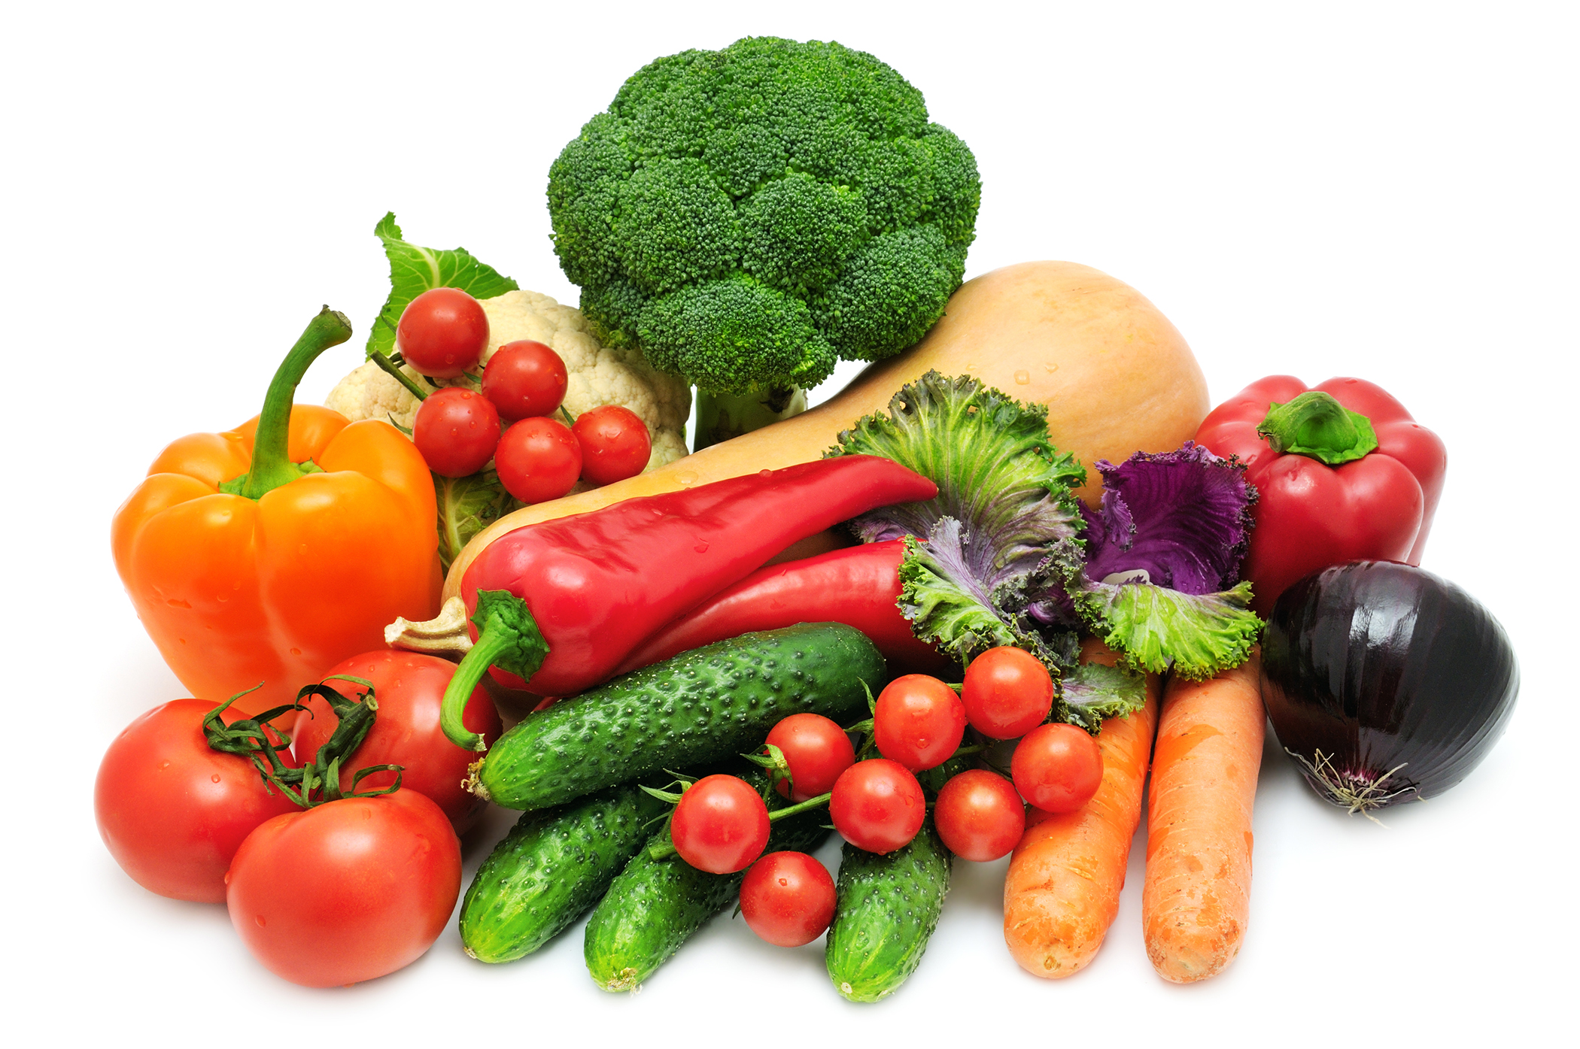](http://www.google.com/url?sa=i&rct=j&q=&esrc=s&source=images&cd=&cad=rja&uact=8&ved=0ahUKEwjTgYT-x_LKAhUKKCYKHfaaAn8QjRwIBw&url=http://blogs.extension.iastate.edu/foodsavings/2014/06/30/will-eating-more-vegetables-cause-you-to-gain-weight/&psig=AFQjCNEHqR1ana0bTuiWNhGiDXWJUtkZjw&ust=1455378080835042)

No more vegatables for a while

This made some kids smile.

**This brought a smile for a while.**

[](https://upload.wikimedia.org/wikipedia/commons/7/71/Smiling_Girl_(Imagicity_837).jpg)

[](http://www.google.com/url?sa=i&rct=j&q=&esrc=s&source=images&cd=&cad=rja&uact=8&ved=0ahUKEwj9-pjMyfLKAhWDXiYKHTJhCCgQjRwIBw&url=http://sabrinagiselle.blogspot.com/2009/02/smart-video.html&psig=AFQjCNG_jANe3oR7eEw4Dd6pjOMByEkABw&ust=1455378492301465)

**Do you think Amelia would say**

**Less vegatables for a while would be OK.**

Replace with child’s name and photo

[](https://www.google.com/url?sa=i&rct=j&q=&esrc=s&source=images&cd=&cad=rja&uact=8&ved=0ahUKEwikj-P3wozMAhUCjz4KHdX3BpoQjRwIBw&url=https://pixabay.com/en/girl-young-blue-eyes-look-looking-545510/&psig=AFQjCNG7ynn76sexEoPYz9Od2pSPmWw2Xw&ust=1460668118494125)

**A pity and for parents a little sad**

**But the real problem – No sugar to be had,**

**And without sugar so sweet**

**No candy or a chocolate treat.**

[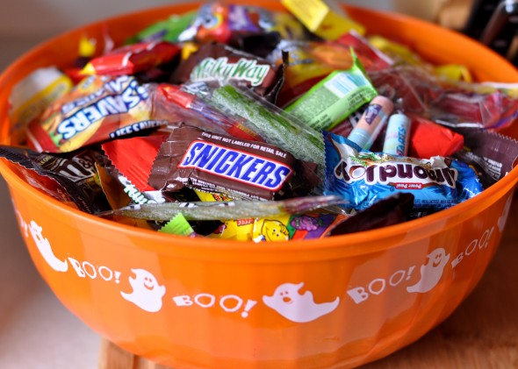](http://www.google.com/url?sa=i&rct=j&q=&esrc=s&source=images&cd=&cad=rja&uact=8&ved=0ahUKEwir5_K12_LKAhVGWCYKHfHJBj8QjRwIBw&url=http://realnutritionnyc.com/2015/11/03/5-things-to-do-with-leftover-halloween-candy/&psig=AFQjCNG-oBfeQ0yswnI0ihEcPNkKWjfftA&ust=1455383214274492)

[](http://www.google.com/url?sa=i&rct=j&q=&esrc=s&source=images&cd=&cad=rja&uact=8&ved=0ahUKEwifwoDZ5uHNAhUGzz4KHQshCGcQjRwIBw&url=http%3A%2F%2Fwww.uvm.edu%2F~mmmoyer%2FCeleste%2FJan2011%2F&psig=AFQjCNGC-T15ct8oFyWd0Xr2ipt-lPCyxQ&ust=1467996225449311)

“Without sugar we will have to stop

having cake or soda pop.”

Insert Parent Picture

[](http://www.google.com/url?sa=i&rct=j&q=&esrc=s&source=images&cd=&cad=rja&uact=8&ved=0ahUKEwjdxvij3PLKAhVCPiYKHQUyAjsQjRwIBw&url=http://fox59.com/2013/07/30/cake-boss-coming-to-indy-giving-away-10000-cakes-on-monument-circle/&psig=AFQjCNGthMCUXpFST0XxJkSvf53RjbWxSg&ust=1455383514853370)

[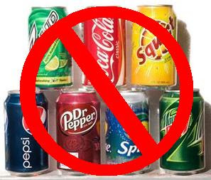](http://www.google.com/url?sa=i&rct=j&q=&esrc=s&source=images&cd=&cad=rja&uact=8&ved=0ahUKEwibwIzj3PLKAhXPciYKHRFeCX0QjRwIBw&url=http://ac-personaltrainer.blogspot.com/&psig=AFQjCNEVqz_UtvxC2AGa3vqG3QKrRNfN8A&ust=1455383587053066)

**The government was in quite a stew about what to do.**

**With this bug intrusion**

**Was there a wise solution?**

**It would remain to be seen**

**If there would be a Halloween!!!**

**There was a great debate**

**The politicians talked and talked until very late.**

[](http://www.google.com/url?sa=i&rct=j&q=&esrc=s&source=images&cd=&cad=rja&uact=8&ved=0ahUKEwiz1M-r4PLKAhVDJCYKHaqPBt8QjRwIBw&url=http://washington.org/topics/us-capitol&psig=AFQjCNHDBGCONzpUBFLpED5O9RzPp8FXoQ&ust=1455384618811772)

**One said “what about honey instead?”**

**Others said “grow up and use your head.”**

**There was only arguing you see**

**They just couldn’t agree.**

**They were incorrigible**

**and the result would be horrible.**

‘

**“For Halloween we confess**

**A scoop of ice cream or pudding**

**Into the bags would be a frightful mess.”**

[](http://www.google.com/url?sa=i&rct=j&q=&esrc=s&source=images&cd=&cad=rja&uact=8&ved=0ahUKEwj_6vP50MPLAhUMdD4KHbtxAHgQjRwIBw&url=http://stopsellingvanillaicecream.com/&psig=AFQjCNExxrO7aII5GS7sOWkCxCo5cZ3liA&ust=1458163506867140)[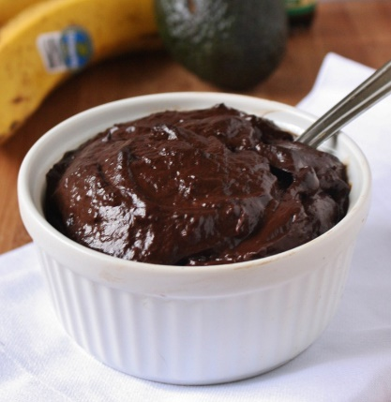](http://www.google.com/url?sa=i&rct=j&q=&esrc=s&source=images&cd=&cad=rja&uact=8&ved=0ahUKEwjXqd7t0cPLAhVGrD4KHZimAXgQjRwIBw&url=http://www.thewannabechef.net/2011/11/14/raw-dark-chocolate-peppermint-pudding/&psig=AFQjCNEknZIgqmSIOH7AuSLDobOAitPNUg&ust=1458163824948465)

[](http://www.google.com/url?sa=i&rct=j&q=&esrc=s&source=images&cd=&cad=rja&uact=8&ved=0ahUKEwjPs5fhkdLLAhXnvIMKHdh8BQUQjRwIBw&url=http://www.scarymommy.com/really-important-stuff-my-kids-have-taught-me/&psig=AFQjCNHCgAMMlRyG2indpZjvoMScszMGgg&ust=1458661669582288)

[](http://www.google.com/url?sa=i&rct=j&q=&esrc=s&source=images&cd=&cad=rja&uact=8&ved=0ahUKEwjG4q_WkNLLAhViyYMKHQZ0BQsQjRwIBw&url=http://nom-nom-food10.blogspot.com/2010/10/ooey-gooey-caramel-covered-apples-aka.html&psig=AFQjCNHCgAMMlRyG2indpZjvoMScszMGgg&ust=1458661669582288)[](http://www.google.com/url?sa=i&rct=j&q=&esrc=s&source=images&cd=&cad=rja&uact=8&ved=0ahUKEwj71urgkNLLAhXDuoMKHZrqAU4QjRwIBw&url=http://blog.asha.org/2014/09/25/you-want-my-kid-to-play-in-food-seriously/&psig=AFQjCNHCgAMMlRyG2indpZjvoMScszMGgg&ust=1458661669582288)

[](http://www.google.com/url?sa=i&rct=j&q=&esrc=s&source=images&cd=&cad=rja&uact=8&ved=0ahUKEwiBk5ilkdLLAhWkm4MKHW5qDLwQjRwIBw&url=http://centrikid.com/tag/messygames/&psig=AFQjCNHCgAMMlRyG2indpZjvoMScszMGgg&ust=1458661669582288)

[](http://www.google.com/url?sa=i&rct=j&q=&esrc=s&source=images&cd=&cad=rja&uact=8&ved=0ahUKEwigpLftkNLLAhXBmIMKHYXVBFsQjRwIBw&url=http://themilliondollarserver.com/20-things-your-server-wished-you-knew/&psig=AFQjCNHCgAMMlRyG2indpZjvoMScszMGgg&ust=1458661669582288)

**“It’s a bitter pill**

**But we need to pass**

**the No Halloween bill.”**

[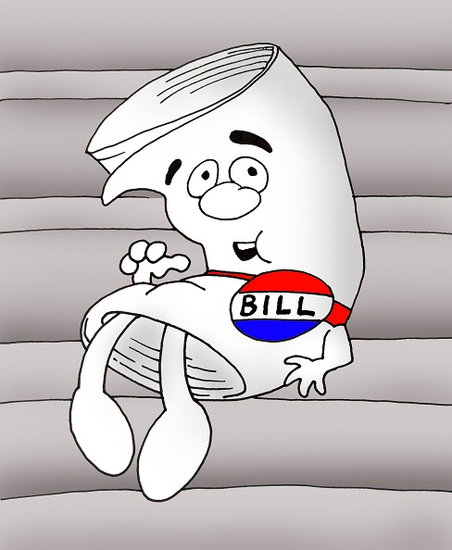](http://www.google.com/url?sa=i&rct=j&q=&esrc=s&source=images&cd=&cad=rja&uact=8&ved=0ahUKEwj-r5Cs7fLKAhXH6CYKHZYJBJ4QjRwIBw&url=http://massbike.org/blog/2013/01/25/massbike-gets-to-work-with-the-new-legislature/&psig=AFQjCNGEgvhy-MhzfZZ1HqCBQSD_xV3e8A&ust=1455387927990275)

[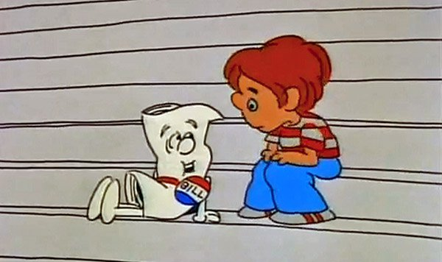](https://www.google.com/url?sa=i&rct=j&q=&esrc=s&source=images&cd=&cad=rja&uact=8&ved=0ahUKEwjGl-jI7fLKAhUFKyYKHXdlDT8QjRwIBw&url=https://sayanythingblog.com/entry/legislature-passed-649-of-918-proposed-bills-in-the-first-half/&psig=AFQjCNGEgvhy-MhzfZZ1HqCBQSD_xV3e8A&ust=1455387927990275)

[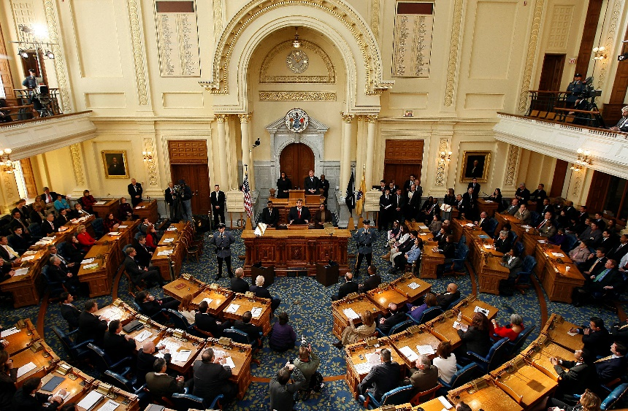](http://www.google.com/url?sa=i&rct=j&q=&esrc=s&source=images&cd=&cad=rja&uact=8&ved=0ahUKEwjipL3d7fLKAhVDbSYKHUZ8Df8QjRwIBw&url=http://addictions.camdencounty.com/n-j-legislature-tackles-addiction-list-of-bills-included-in-major-package/&psig=AFQjCNGEgvhy-MhzfZZ1HqCBQSD_xV3e8A&ust=1455387927990275)

**You see they just couldn’t agree on a decree.**

**Adults, teens, kids and even babies**

**All said “it’s the worst**

**If I can’t go out October thirty-first**

**We are doomed if we can’t go out costumed.”**

[](http://www.google.com/url?sa=i&rct=j&q=&esrc=s&source=images&cd=&cad=rja&uact=8&ved=0ahUKEwjL08qhofrKAhWClYMKHb_9AZkQjRwIBw&url=http://www.brandbacker.com/the-blog/2015/10/the-top-halloween-costumes-for-2015-according-to-bloggers/&psig=AFQjCNHYhhcB1JJrHABHxsj252q2--KV2Q&ust=1455641310633993)

[](http://www.google.com/url?sa=i&rct=j&q=&esrc=s&source=images&cd=&cad=rja&uact=8&ved=0ahUKEwil4668ofrKAhUhnoMKHdVhCpwQjRwIBw&url=http://parade.com/433128/lindsaylowe/the-top-10-most-searched-halloween-costumes-this-year/&psig=AFQjCNHYhhcB1JJrHABHxsj252q2--KV2Q&ust=1455641310633993)

[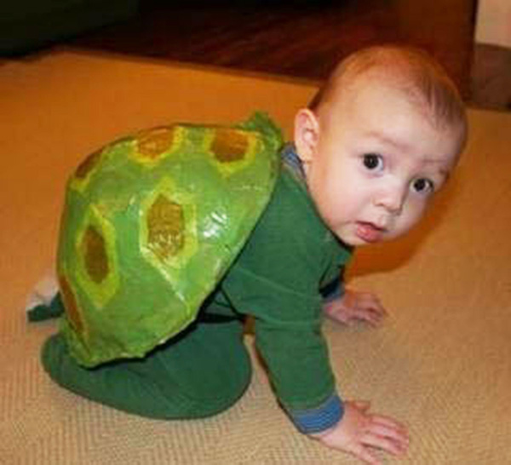](http://www.google.com/url?sa=i&rct=j&q=&esrc=s&source=images&cd=&cad=rja&uact=8&ved=0ahUKEwiVwpXVoPrKAhVhuIMKHX1MAp0QjRwIBw&url=http://www.sunnyskyz.com/blog/456/The-26-Best-Halloween-Costumes-For-Babies&psig=AFQjCNHYhhcB1JJrHABHxsj252q2--KV2Q&ust=1455641310633993)

[](http://www.google.com/url?sa=i&rct=j&q=&esrc=s&source=images&cd=&cad=rja&uact=8&ved=0ahUKEwi-g5atnvrKAhXCtoMKHUpNAJ4QjRwIBw&url=http://www.toysrus.com/products/baby-and-toddler-girl-halloween-costumes.jsp&psig=AFQjCNHYhhcB1JJrHABHxsj252q2--KV2Q&ust=1455641310633993)

[](http://www.google.com/url?sa=i&rct=j&q=&esrc=s&source=images&cd=&cad=rja&uact=8&ved=0ahUKEwiW0uKKofrKAhXFuIMKHTxNCJ0QjRwIBw&url=http://www.moneycrashers.com/cheap-halloween-costumes-tips/&psig=AFQjCNHYhhcB1JJrHABHxsj252q2--KV2Q&ust=1455641310633993)

**Doomed!!**

[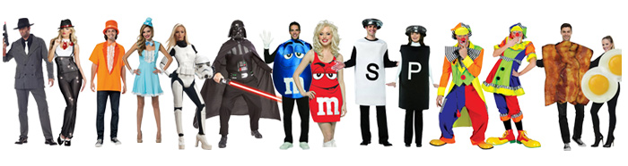](http://www.google.com/url?sa=i&rct=j&q=&esrc=s&source=images&cd=&cad=rja&uact=8&ved=0ahUKEwimkrmeoPrKAhXjnIMKHVb3DZsQjRwIBw&url=http://www.halloweenexpress.com/couples-costume-ideas.php&psig=AFQjCNHYhhcB1JJrHABHxsj252q2--KV2Q&ust=1455641310633993)

**There would be such a shout**

**“We want to dress up and go out.”**

**You can bet**

**Every kid, even Amelia would be upset.**

g

[](http://www.google.com/url?sa=i&rct=j&q=&esrc=s&source=images&cd=&cad=rja&uact=8&ved=0ahUKEwi7luffnfrKAhXLk4MKHTniC6EQjRwIBw&url=http://www.target.com/c/halloween-party-supplies-holidays/-/N-5xt2o?ref%3Dtgt_adv_xasd0001%26AFID%3DPerformics_Online%20Savings_0004c8968615ad1b0a2a18462e000496%26LNM%3DExclusive%20Offer%20-%20Save%2020%25%20on%20any%20Halloween%20Costume%20with%20Promo%20Code%20HALLOWN20&psig=AFQjCNHYhhcB1JJrHABHxsj252q2--KV2Q&ust=1455641310633993)

[](http://www.google.com/url?sa=i&rct=j&q=&esrc=s&source=images&cd=&cad=rja&uact=8&ved=0ahUKEwiYrYf-nvrKAhVqnIMKHXsCCf0QjRwIBw&url=http://hubpages.com/holidays/30-Diy-Halloween-Costume-Ideas&psig=AFQjCNHYhhcB1JJrHABHxsj252q2--KV2Q&ust=1455641310633993)

**Replace with child’s Photo if available.**

[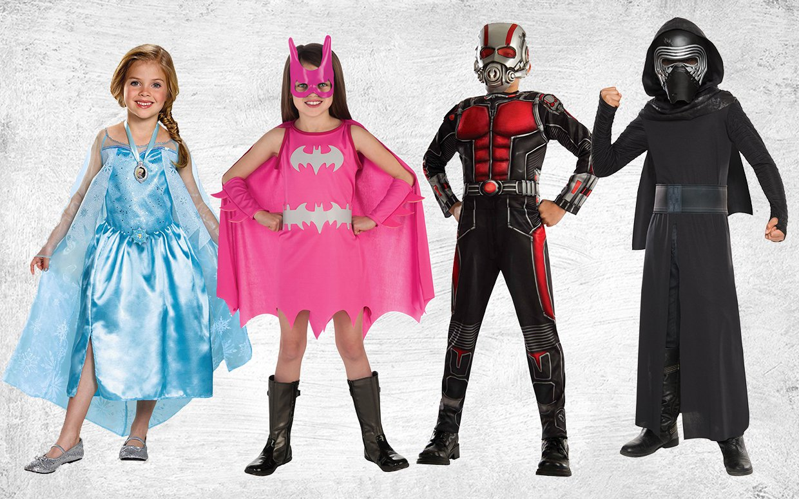](http://www.google.com/url?sa=i&rct=j&q=&esrc=s&source=images&cd=&cad=rja&uact=8&ved=0ahUKEwjx2aX_nPrKAhXKtIMKHSDdAZgQjRwIBw&url=http://parade.com/428452/sphillips/the-top-girls-and-boys-halloween-costumes-of-2015/&psig=AFQjCNHYhhcB1JJrHABHxsj252q2--KV2Q&ust=1455641310633993)

***“What?” All the children said.***

***“You must be out of your head.***

***There must be a way to save the day.***

***We want to go out and say***

**Trick or treat, money or eat.”**

[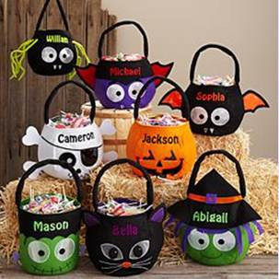](http://www.google.com/url?sa=i&rct=j&q=&esrc=s&source=images&cd=&cad=rja&uact=8&ved=0ahUKEwjT5pW4s_rKAhXHvIMKHYyGCeMQjRwIBw&url=http://www.mommyfactor.net/2013/09/personal-creations-halloween-treat-bags.html&psig=AFQjCNEZm3eeovmHaMGUUwpysRBTeclqsw&ust=1455647155644752)

[](http://www.google.com/url?sa=i&rct=j&q=&esrc=s&source=images&cd=&cad=rja&uact=8&ved=0ahUKEwiN0ffXsvrKAhWLvYMKHak4BUoQjRwIBw&url=http://veemd.com/2015/10/14/tips-to-make-halloween-safe/&psig=AFQjCNEZm3eeovmHaMGUUwpysRBTeclqsw&ust=1455647155644752)

[](https://www.google.com/imgres?imgurl=http://bloximages.chicago2.vip.townnews.com/thehawkeye.com/content/tncms/assets/v3/editorial/0/4e/04effb8d-ac06-5928-9089-597f48731688/5631151c9535d.image.jpg?resize%3D1200,707&imgrefurl=http://www.thehawkeye.com/entertainment/weekend/trick-or-treat-times-set/article_872612b4-b1a5-5979-977c-d632b23a4e11.html&h=707&w=1200&tbnid=YDwFlmlclcmYPM:&docid=BkH5MSarOFnggM&ei=MhjCVtP1O-mwjgTRq7SIAw&tbm=isch&ved=0ahUKEwjT1v-tsvrKAhVpmIMKHdEVDTEQMwhVKC0wLQ)

**“It would be a sin**

**If we couldn’t carve a pumpkin.”**

[](http://www.google.com/url?sa=i&rct=j&q=&esrc=s&source=images&cd=&cad=rja&uact=8&ved=0ahUKEwiJ3oCLsvrKAhXJwj4KHajvDAIQjRwIBw&url=http://athensohio.com/blog-posts/in-search-of-the-6-best-pumpkin-patches-near-athens/&psig=AFQjCNFW3ytdV-MqSy_A3V2NFrGWiIYLYg&ust=1455646973518184)

**When the children heard the cancel word**

**Some of them were confused & sad**

**Some were very mad.**

[](http://www.google.com/url?sa=i&rct=j&q=&esrc=s&source=images&cd=&cad=rja&uact=8&ved=0ahUKEwjB5vmAr6fLAhXC7iYKHTiqABEQjRwIBw&url=http://clipartfreefor.com/files/1/30401_stingray-clip-art.html&psig=AFQjCNGtyB9aZ-XrjC8K1jo5sDrA4cd89Q&ust=1457192384569063)

**Imagine what Amelia would say**

**About canceling the holiday.**

**“Cancel Halloween what a thought.**

**The children will be distraught.**

[](https://www.google.com/url?sa=i&rct=j&q=&esrc=s&source=images&cd=&cad=rja&uact=8&ved=0ahUKEwikj-P3wozMAhUCjz4KHdX3BpoQjRwIBw&url=https://pixabay.com/en/girl-young-blue-eyes-look-looking-545510/&psig=AFQjCNG7ynn76sexEoPYz9Od2pSPmWw2Xw&ust=1460668118494125)

**Replace with child’s Photo if available.**

**All the parents all over town**

**Were jumping up and down with a frown**

**For their girls and boys were about to lose one of their joys.**

[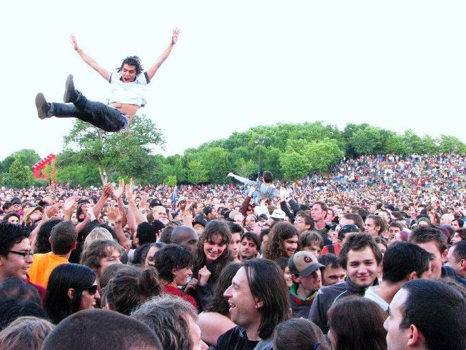](https://www.google.com/url?sa=i&rct=j&q=&esrc=s&source=images&cd=&cad=rja&uact=8&ved=0ahUKEwjA7pCrwqfLAhUHMyYKHWpfALsQjRwIBw&url=https://www.flickr.com/photos/larslars/718618057&psig=AFQjCNG-JaUvYXvy4WVJW7N5qhNMU1pSvA&ust=1457197555619556)

[](http://www.google.com/url?sa=i&rct=j&q=&esrc=s&source=images&cd=&cad=rja&uact=8&ved=0ahUKEwiW3dvlwqfLAhXDPCYKHcNhAl8QjRwIBw&url=http://www.telegraph.co.uk/education/educationpicturegalleries/11033897/A-level-results-in-pictures-Students-jump-for-joy-as-they-receive-their-grades.html&psig=AFQjCNG-JaUvYXvy4WVJW7N5qhNMU1pSvA&ust=1457197555619556)

**But first one farmer and then a bunch**

**Said “we know what to do in this crunch.**

**It just happens we have sugar beets**

**that can be used to make Halloween treats.”**

[](http://www.google.com/url?sa=i&rct=j&q=&esrc=s&source=images&cd=&cad=rja&uact=8&ved=0ahUKEwjqyfisuKXLAhUrsYMKHR6QAngQjRwIBw&url=http://billingsgazette.com/news/state-and-regional/montana/beet-farmers-are-seeking-a-way-out-of-the-sweet/article_9fb46c05-2c14-5bff-9748-5e0ad741bc12.html&psig=AFQjCNGwdcpN5qJcH3XNFMlnfBIulfBThg&ust=1457126180314444)

**He called his senator**

**and said, “What for?**

**It is obscene**

**To Cancel Halloween.”**

[](http://www.google.com/url?sa=i&rct=j&q=&esrc=s&source=images&cd=&cad=rja&uact=8&ved=0ahUKEwinvbPB1afLAhWBzoMKHdEyCR4QjRwIBw&url=http://www.hcrepublican.com/senators/&psig=AFQjCNF9VY1ZNOrcUY-cSzoHfIF3Bndb8Q&ust=1457202755969523)

**But the senator said, “Sorry, but every bag needs “beet” on the label before it can go to a kitchen table.”**

**Still the farmer didn’t quit**

**He called the sugar company and asked, “Can you do your bit?”**

**He was told**

**“We can arrange**

**for the label change,**

**but To get it done**

**we need many a ton.**

**It would be a pity**

**No Haloween for St Lois Park, or any city.”**

.

[](http://www.google.com/url?sa=i&rct=j&q=&esrc=s&source=images&cd=&cad=rja&uact=8&ved=0ahUKEwiL59-2uaXLAhXHlIMKHeJBDssQjRwIBw&url=http://www.grocery.com/american-crystal-sugar/&psig=AFQjCNGwdcpN5qJcH3XNFMlnfBIulfBThg&ust=1457126180314444)

Change city naame

**As to beets, some farmers had miles of piles.**



[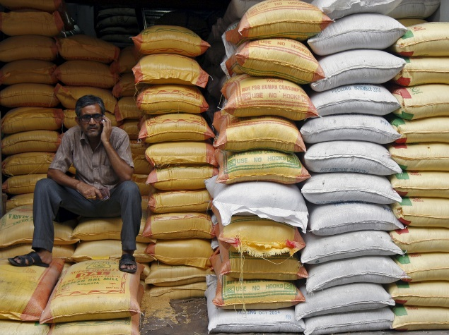](http://www.google.com/url?sa=i&rct=j&q=&esrc=s&source=images&cd=&cad=rja&uact=8&ved=0ahUKEwixs72Ciq_LAhVDWT4KHartDgEQjRwIBw&url=http://gadgets.ndtv.com/telecom/news/farmers-to-get-free-sms-alerts-on-extreme-weather-conditions-with-nowcast-705471&psig=AFQjCNFE_C8jlKMhkLKUAIMX1YKh14vg6Q&ust=1457457309281659)

**Some had it in bags**

**All that was need was new tags.**

[](https://www.google.com/url?sa=i&rct=j&q=&esrc=s&source=images&cd=&cad=rja&uact=8&ved=0ahUKEwiI2t_Ek6_LAhUHuYMKHQJ8DxEQjRwIBw&url=https://www.sugarland.com/photos/view_photo.php?photo_id%3D469&psig=AFQjCNFz7u8uuF7fDOVlcrqteigKvcwbBw&ust=1457459891323746)

**Then the factory called – the news is bad**

**Right now we need every last beet to be had.**

[](http://www.google.com/url?sa=i&rct=j&q=&esrc=s&source=images&cd=&cad=rja&uact=8&ved=0ahUKEwil6KDJjK_LAhVEVT4KHTTuDvEQjRwIBw&url=http://www.foodnavigator.com/Market-Trends/Sugar-tops-UK-food-concerns&psig=AFQjCNFC5TilX2ZVs1B1UvBOu8kGK-9EFA&ust=1457457908351131)

**We need to have enough**

**For all the sugary stuff.**

**The farmer was determined not to fail.**

**He called others and sent an e-mail.**

**“You need to dig up every mound**

**We need it all out of the ground.”**

[](https://www.google.com/imgres?imgurl=http://static.planetminecraft.com/files/resource_media/screenshot/1242/road_sign_need_help_950918_thumb_2889558_3868910_lrg.jpg&imgrefurl=http://www.planetminecraft.com/blog/help-1536308/&h=220&w=220&tbnid=C1OzlWSCpgN7RM:&docid=QbgkpDH7NPthHM&ei=xJjhVsGDLKm8jgSr6bLQDg&tbm=isch&ved=0ahUKEwjB9b6qvbbLAhUpnoMKHau0DOoQMwhpKEEwQQ)

**Across the land**

**Some picked by machine, some by hand.**

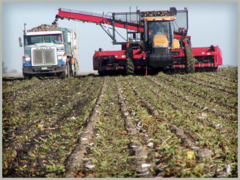

[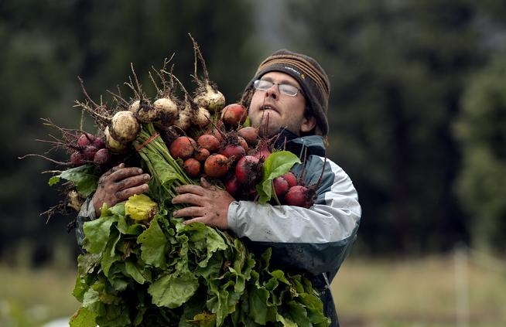](http://www.google.com/url?sa=i&rct=j&q=&esrc=s&source=images&cd=&cad=rja&uact=8&ved=0ahUKEwjb8bqSia_LAhWJcj4KHQ-7AwIQjRwIBw&url=http://www.denverpost.com/ci_26569202/golden-farmer-running-national-grant-thanks-regis-chef&psig=AFQjCNGfIHl-qZ4z3GEfRDtdYmzIe8ZIPg&ust=1457456859583933)

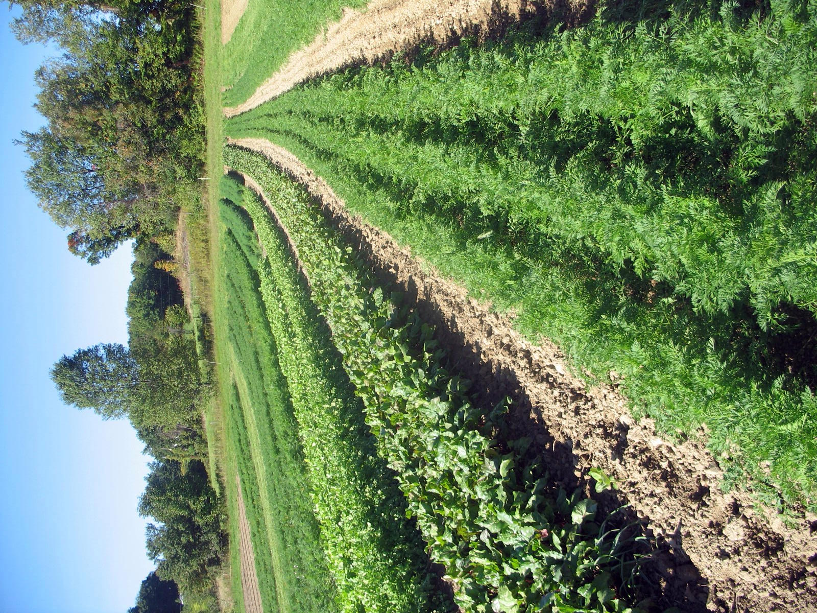

**There were lots and lots of rows**

**And they used lots and lots of hoes.**

To the fields came the girls and boys

Later they could play with their toys.

[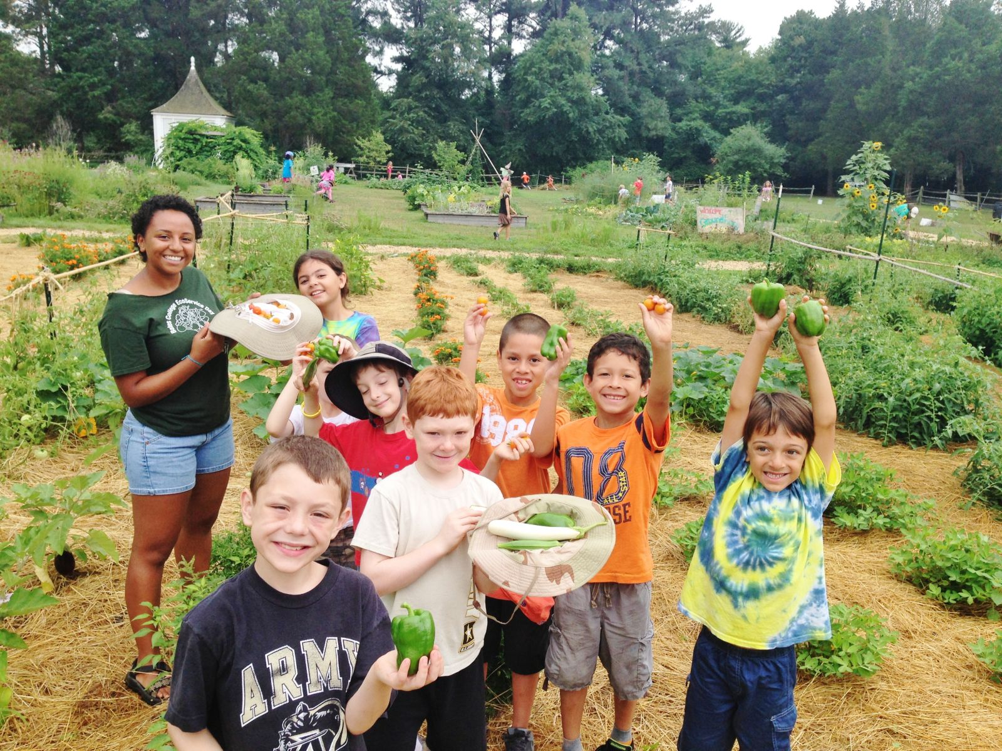](http://www.google.com/url?sa=i&rct=j&q=&esrc=s&source=images&cd=&cad=rja&uact=8&ved=0ahUKEwiSw8Cni6_LAhXD8z4KHQqwBgIQjRwIBw&url=http://arcadiafood.org/arcadia-farm-camp&psig=AFQjCNH0fvke89QzV-JkPEVjR0E_iTwTew&ust=1457457615502170)

[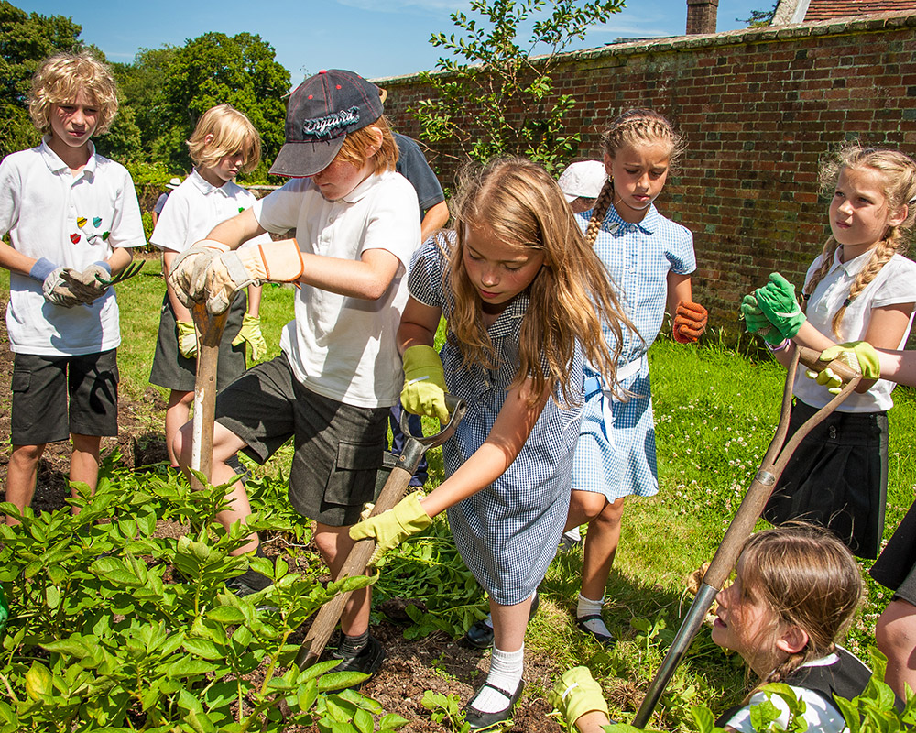](http://www.google.com/url?sa=i&rct=j&q=&esrc=s&source=images&cd=&cad=rja&uact=8&ved=0ahUKEwiyoLKBi6_LAhXMVD4KHf3ODgEQjRwIBw&url=http://groweatgather.co.uk/countryside-classroom/&psig=AFQjCNH0fvke89QzV-JkPEVjR0E_iTwTew&ust=1457457615502170)

**They said “it would be neat to save Halloween with a simple beet.**

**To get sugar to the store**

**We can dig up even more.”**

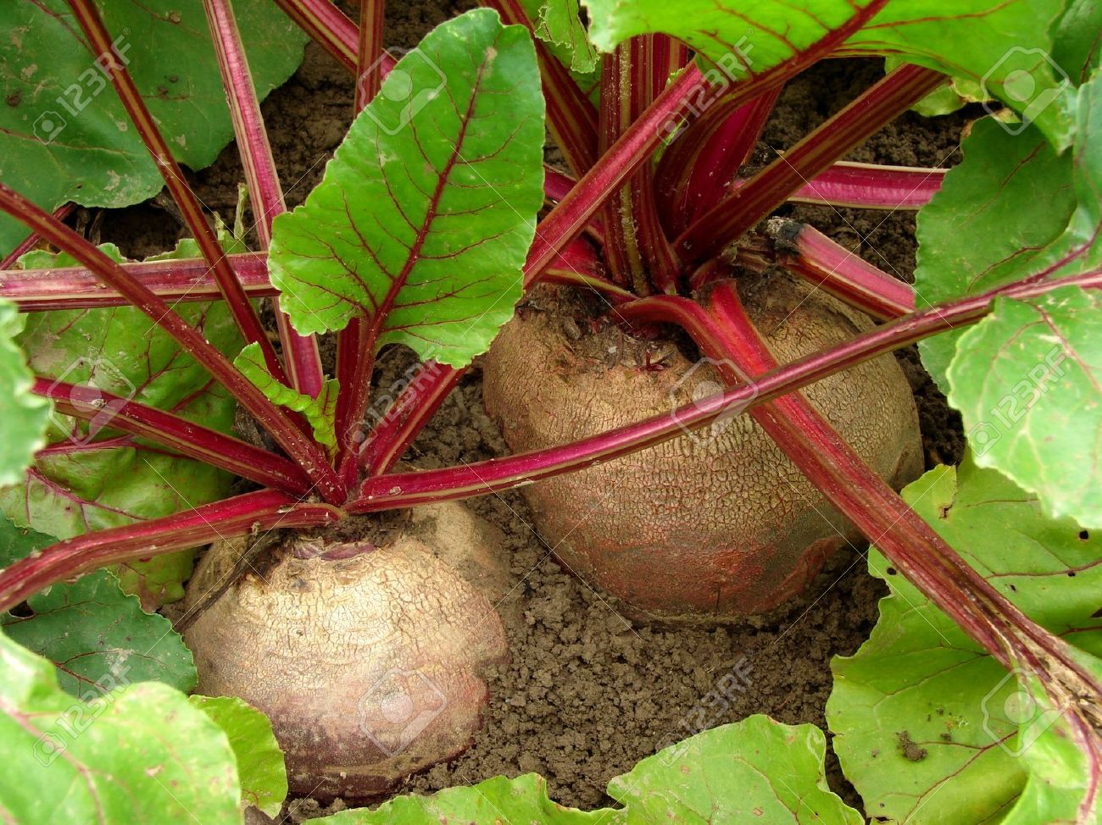

**Then the factory called with trouble.**

**We are afraid you are on a time bubble.**

[](https://www.google.com/url?sa=i&rct=j&q=&esrc=s&source=images&cd=&cad=rja&uact=8&ved=0ahUKEwjov77Zk6_LAhWpg4MKHbrnA40QjRwIBw&url=https://www.michigansugar.com/community/scholarships/&psig=AFQjCNFz7u8uuF7fDOVlcrqteigKvcwbBw&ust=1457459891323746)

[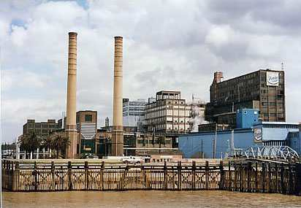](http://www.google.com/url?sa=i&rct=j&q=&esrc=s&source=images&cd=&cad=rja&uact=8&ved=0ahUKEwjPj5zplK_LAhVLdD4KHegQAwAQjRwIBw&url=http://mikehammer.tripod.com/3worlds.htm&psig=AFQjCNESioCwGynWGCuhj8amnJN9snVqpA&ust=1457460177032815)

“We fear

You don’t have time to get the beets here.

We don’t see how

you can get them to us now.”

**All the farmer could say was …**

[](http://www.google.com/url?sa=i&rct=j&q=&esrc=s&source=images&cd=&cad=rja&uact=8&ved=0ahUKEwjjl4-5j_DKAhUENSYKHcU9AjUQjRwIBw&url=http://www.independenttraveler.com/travel-tips/air-travel/what-not-to-do-at-the-airport&psig=AFQjCNHwCq-rWkSaobGbTJXjMb1nbTwpVQ&ust=1455294009987026)

**“What do you mean?**

**Halloween is our dream.”**

[](http://www.google.com/url?sa=i&rct=j&q=&esrc=s&source=images&cd=&cad=rja&uact=8&ved=0ahUKEwjttcibxrbLAhVDnIMKHVUxCbEQjRwIBw&url=http://avathacis.blogspot.com/2012/08/lucid-dreaming-guide-part-2-dild.html&psig=AFQjCNFnNOZIyG7adep8SvflroBbaekcnA&ust=1457711685125763)

**They said,**

**“well you see it is too expensive by plane.**

[](https://www.google.com/imgres?imgurl=http://www.multilinkscargo.com/images/cargo%20Plane.jpg&imgrefurl=http://www.multilinkscargo.com/services.html&h=1370&w=2048&tbnid=sIyArhnqTU9lhM:&docid=S91kqjuCZWFwlM&ei=S6zhVvnTKcG7mwHd3bz4Bw&tbm=isch&ved=0ahUKEwi5pZf6z7bLAhXB3SYKHd0uD38QMwhBKBwwHA)

[](http://www.google.com/url?sa=i&rct=j&q=&esrc=s&source=images&cd=&cad=rja&uact=8&ved=0ahUKEwjDvMKd0LbLAhWBcT4KHWi2CDoQjRwIBw&url=http://www.gettyimages.com/detail/illustration/cargo-plane-royalty-free-illustration/537816877&bvm=bv.116573086,d.eWE&psig=AFQjCNFhzrj_d08Tl6YBHq6zZljmkN7bFw&ust=1457716684059668)

**And it’s too slow by train.**

[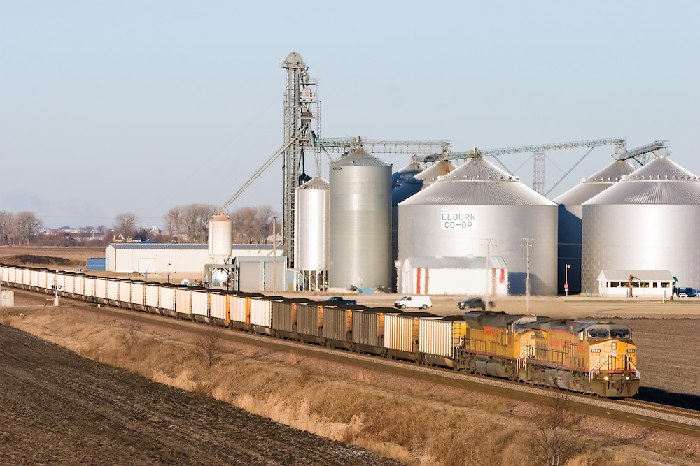](http://www.google.com/url?sa=i&rct=j&q=&esrc=s&source=images&cd=&cad=rja&uact=8&ved=0ahUKEwj7loyE07bLAhVGeD4KHY8vAjkQjRwIBw&url=http://nicksuydam.photoshelter.com/gallery/Union-Pacific-Railroad-Stock-Photos/G0000y4EjfZEa.Hc/&psig=AFQjCNHpw1T9BGXFqbVZtatNWUj6XxGiFQ&ust=1457717443769392)

[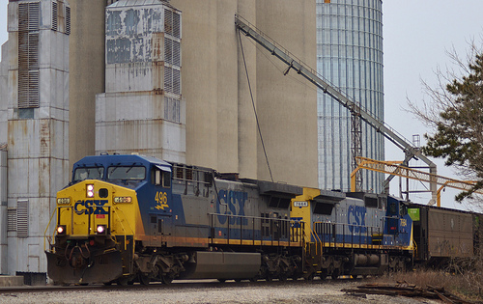](http://www.google.com/url?sa=i&rct=j&q=&esrc=s&source=images&cd=&cad=rja&uact=8&ved=0ahUKEwjlwvLH07bLAhXGNj4KHT4ACTUQjRwIBw&url=http://railroadfan.com/phpbb/viewtopic.php?f%3D6%26t%3D27024&psig=AFQjCNHpw1T9BGXFqbVZtatNWUj6XxGiFQ&ust=1457717443769392)

“No way to save Halloween day,”

The farmer thought “No plane, no train, no luck,

were stuck.”

“From giving the children hope I’ve been a dope.

Sad to say no Halloween day.

**This year no candy bars.**

**It’s too slow loading the train cars.**

**It’s just not in the stars.”**

[](http://www.google.com/url?sa=i&rct=j&q=&esrc=s&source=images&cd=&cad=rja&uact=8&ved=0ahUKEwikoomn-LjLAhXGVD4KHbTpCHUQjRwIBw&url=http://www.123rf.com/stock-photo/mope.html&psig=AFQjCNGOWRAhmOY8aL1mTzaeNc4dEmBXPA&ust=1457796221140229)

[](http://www.google.com/url?sa=i&rct=j&q=&esrc=s&source=images&cd=&ved=0ahUKEwic85Tt-bjLAhVBez4KHf-PA3QQjRwIBw&url=http://deehobbit.com/2015/04/12/office-arrangement-awesomeness-makes-today-a-magic-monday/&psig=AFQjCNHewmRtK6wA_f2-WE3WxfVHx_sLOg&ust=1457796453222559)

[](http://www.google.com/url?sa=i&rct=j&q=&esrc=s&source=images&cd=&cad=rja&uact=8&ved=0ahUKEwiIncDI-LjLAhUBdD4KHXleAn0QjRwIBw&url=http://www.stockphotos.ro/sad-child-crying-image24040224.html&psig=AFQjCNGOWRAhmOY8aL1mTzaeNc4dEmBXPA&ust=1457796221140229)

[](http://www.google.com/url?sa=i&rct=j&q=&esrc=s&source=images&cd=&cad=rja&uact=8&ved=0ahUKEwj914if-7jLAhUINj4KHZybCHYQjRwIBw&url=http://sccougar.com/2016/02/26/party-all-night-sleep-all-day-songtext-von-sean-kingston.html&psig=AFQjCNHewmRtK6wA_f2-WE3WxfVHx_sLOg&ust=1457796453222559)

[](https://www.google.com/url?sa=i&rct=j&q=&esrc=s&source=images&cd=&cad=rja&uact=8&ved=0ahUKEwjq9KK9-7jLAhWMVz4KHYWUAH8QjRwIBw&url=https://blue1004.wordpress.com/2011/03/25/second-impression-review-49-days/&psig=AFQjCNHewmRtK6wA_f2-WE3WxfVHx_sLOg&ust=1457796453222559)

[](http://www.google.com/url?sa=i&rct=j&q=&esrc=s&source=images&cd=&cad=rja&uact=8&ved=0ahUKEwjXvvGZ-bjLAhVGOD4KHei6AYIQjRwIBw&url=http://www.huffingtonpost.com/samantha-rodman-phd/what-should-i-do-when-my-child-fake-cries_b_7248816.html&psig=AFQjCNHewmRtK6wA_f2-WE3WxfVHx_sLOg&ust=1457796453222559)

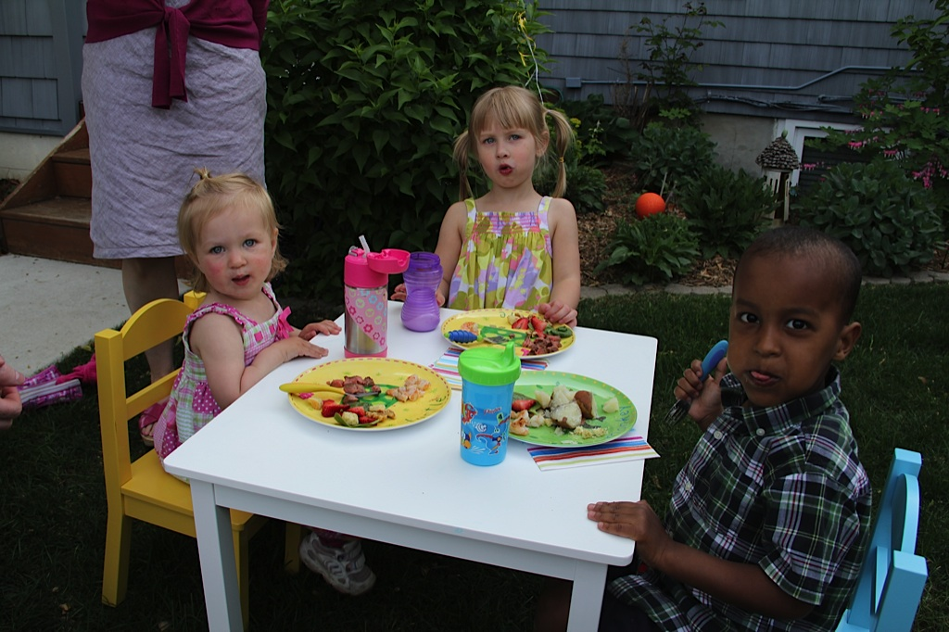

[](http://www.google.com/url?sa=i&rct=j&q=&esrc=s&source=images&cd=&cad=rja&uact=8&ved=0ahUKEwiFhbSU-rjLAhXGHT4KHeU4BnoQjRwIBw&url=http://controversialparent.com/your-kids-are-too-entitled-heres-how-you-cancel-christmas/&psig=AFQjCNHewmRtK6wA_f2-WE3WxfVHx_sLOg&ust=1457796453222559)

**“Wait!!”**

“We will not be tardy.

We can save the Halloween party.”

[](http://www.google.com/url?sa=i&rct=j&q=&esrc=s&source=images&cd=&cad=rja&uact=8&ved=0ahUKEwjBu8XT-bbLAhUIVT4KHckMBTgQjRwIBw&url=http://www.business2community.com/strategy/10-ways-to-build-an-idea-factory-within-your-organization-0489150&psig=AFQjCNGIZkKcC5rnScEwWNKcQvgsxVj61g&ust=1457727850328501)

**“Were not stuck**

**Every farmer has a truck**

**We will hit the road with a load**

**Big or small we can do the haul.”**

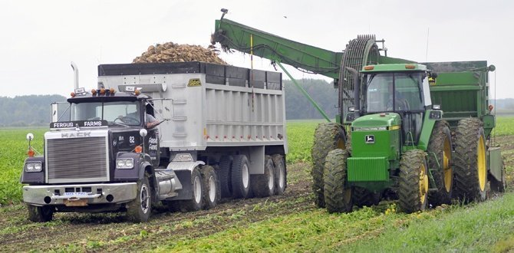

[](https://www.google.com/url?sa=i&rct=j&q=&esrc=s&source=images&cd=&cad=rja&uact=8&ved=0ahUKEwi6oZvsjrfLAhVJwj4KHWCYDzYQjRwIBw&url=https://www.pinterest.com/morningwood74/farm-trucks/&bvm=bv.116573086,d.cWw&psig=AFQjCNFELwO7jRCqXxeTGFm11Gqco1BnSw&ust=1457733519447641)

[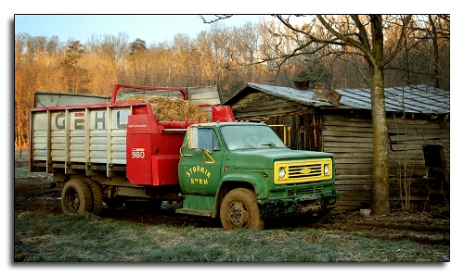](https://www.google.com/url?sa=i&rct=j&q=&esrc=s&source=images&cd=&cad=rja&uact=8&ved=0ahUKEwjZm9qSj7fLAhVDcD4KHYSMBzgQjRwIBw&url=https://pubs.ext.vt.edu/2906/2906-1362/2906-1362.html&bvm=bv.116573086,d.cWw&psig=AFQjCNFELwO7jRCqXxeTGFm11Gqco1BnSw&ust=1457733519447641)

[](https://www.google.com/url?sa=i&rct=j&q=&esrc=s&source=images&cd=&cad=rja&uact=8&ved=0ahUKEwiyssKoj7fLAhWLaT4KHZ1HCjgQjRwIBw&url=https://www.pinterest.com/explore/farm-trucks/&bvm=bv.116573086,d.cWw&psig=AFQjCNFELwO7jRCqXxeTGFm11Gqco1BnSw&ust=1457733519447641)

[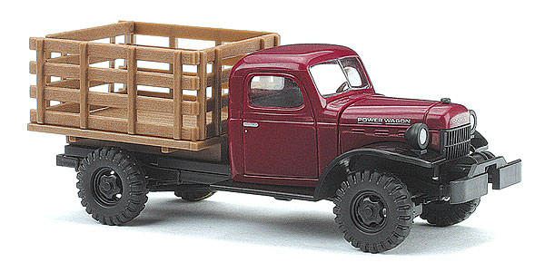](http://www.google.com/url?sa=i&rct=j&q=&esrc=s&source=images&cd=&cad=rja&uact=8&ved=0ahUKEwii0ov9jrfLAhVEOT4KHTpGADoQjRwIBw&url=http://www.dallasmodelworks.com/products/productDetail.asp?ItemNumber%3DBU-189-44001&bvm=bv.116573086,d.cWw&psig=AFQjCNFELwO7jRCqXxeTGFm11Gqco1BnSw&ust=1457733519447641)

[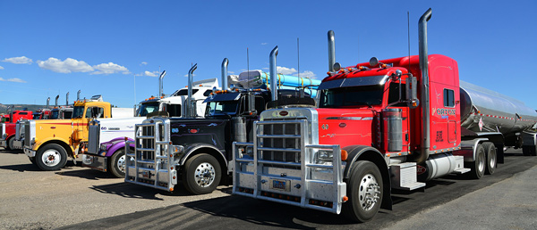](http://www.google.com/url?sa=i&rct=j&q=&esrc=s&source=images&cd=&cad=rja&uact=8&ved=0ahUKEwj128nI9LjLAhVMWz4KHUZXAXUQjRwIBw&url=http://www.commercial-financing-solutions.com/semi-truck/&psig=AFQjCNHXjPrQb3wIAL11dK9G1LF6yozI9Q&ust=1457795146836893)

**The very next day**

**trucks arrived colorful and white.**

**It was quite a sight day and night.**

**Long lines of all kinds.**

**Under the gun they unloaded until there was none. It got very still as the beets went to the sugar mill.**

[](https://www.google.com/url?sa=i&rct=j&q=&esrc=s&source=images&cd=&cad=rja&uact=8&ved=0ahUKEwjqkofWiK_LAhXCdD4KHZBoDAIQjRwIBw&url=https://community.goodgamestudios.com/bigfarm/us/discussion/106509/green-tree-farm-needs-good-farmers&psig=AFQjCNGfIHl-qZ4z3GEfRDtdYmzIe8ZIPg&ust=1457456859583933)

**The farmer said “yippie ki yah.”**

**Then millions said “horray.**

**We have saved the day.”**

**The word went out**

**Millions and millions gave a shout.**

[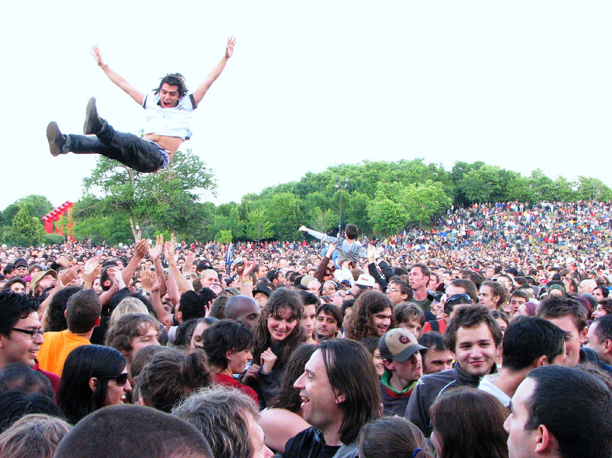](https://www.google.com/url?sa=i&rct=j&q=&esrc=s&source=images&cd=&ved=0ahUKEwicooPnxbnLAhUFSiYKHUTABtUQjRwIBw&url=https://www.flickr.com/photos/larslars/718618057&psig=AFQjCNFxU-VrobsORj3x38pBts4WuwUTHA&ust=1457816842922961)

Even Amelia’s family.



**“Happy Halloween Amelia”**